Assignment 2-Case Study

Stage 4 Lab Activities

Implementing the SmartCare Domain Layer
DESIGN FIRST -> AI PAIR PROGRAMMING -> REVIEW -> VERIFY | 1hour

A - Revisit Approved UML
Confirm responsibilities, attributes and relationships before coding.
Class | Attributes | Responsibilities
Patient | Patient ID, name, contact details | Store patient information and validate updates.
Practitioner | Practitioner ID, name, specialty | Store practitioner information and validates updates
Appointment | Appointment ID, patient, practitioner, date/time, status | Store booking details and control rescheduling, cancellation and completion*.
Relationships
- Each appointments link to exactly one patient and to one practitioner.
- Patients can have many or zero appointments
- Practitioner can as well have many or zero appointments
- Associations not inheritance

B - Implement Patient: AI OFF
Implement Patient with type hints and basic validation.
The class is within the python file called Classes

C - Implement Practitioner: AI OFF
Implement Practitioner with identifier, name and specialty; no database logic.
The class is within the python file called Classes

D - Implement Appointment: AI ON
Give AI the approved Appointment UML, business rules and explicit constraints. Ask it to implement only Appointment and agreed enum/exception.

E - Review Generated Code
Check model consistency, unsupported features, public state mutation, unnecessary inheritance, invented dependencies and error handling.

All These are within the log

F - Manual Behaviour Checks
Create valid objects, test invalid input, cancel a scheduled appointment and attempt an illegal repeated transition.
Testing Final Code of AIgenCode6
I created a valid Patient, Practitioner and Appointment. The appointment was created with a SCHEDULED status. I tested invalid patient and practitioner objects; each raised a TypeError. I then cancelled a scheduled appointment and confirmed its status changed to CANCELLED. Trying to cancel it again raised InvalidStatusTransitionError. I also checked that a completed appointment cannot be rescheduled. These results matched the expected behaviour.
Things I tested

Test | What to do | Expected result | Actual result | Pass/Fail
Create valid objects | Create a Patient, Practitioner and Appointment with valid details. | Objects are created. Appointment status is SCHEDULED. | Objects are created | P
Blank required input | Enter a blank patient name or appointment ID. | Input is rejected. The terminal asks you to retry. | Input is rejected | P
Invalid date input | Enter "abc" at the date/time prompt. | Displays a message and asks you to retry. | Displays error | P
Cancel an appointment | Call cancel() on a scheduled appointment. | Status becomes CANCELLED. The object still exists. | CANCELLED | P
Repeat cancellation | Call cancel() again on that appointment. | Raises InvalidStatusTransitionError. Status stays CANCELLED. | stays CANCELLED | P
Complete an appointment | Call complete() on a new scheduled appointment. | Status becomes COMPLETED. | COMPLETED. | P
Change a completed appointment | Call cancel() on the completed appointment. | Raises InvalidStatusTransitionError. Status stays COMPLETED. | stays COMPLETED | P
Reschedule a scheduled appointment | Call reschedule() with a valid new datetime. | The appointment time changes. Status stays SCHEDULED. | The appointment time changes. Status stays SCHEDULED. | P
Reschedule a cancelled appointment | Call reschedule() after cancellation. | Raises InvalidStatusTransitionError. Time stays unchanged. | Error
Reschedule a completed appointment | Call reschedule() after completion. | Raises InvalidStatusTransitionError. Time stays unchanged. | Error

G - Refactor
Remove unnecessary code and make implementation simpler and design-consistent.
All These are within the log

H - AI Engineering Log
Record prompt, generated contribution, decisions and verification evidence.

AI Error | Prompt to fix | Decision to keep new code | Verification
Appointment attributes are public, so outside code can change its status and other state directly. | “Make Appointment attributes internal using _ names. Keep simple getter methods and update its methods to use the internal attributes.”  The Code is AigenCodeDraft2 | Yes but need to fix and edit other mistakes | Check that getters return the correct values and that cancel() updates _status.
The constructor does not verify that patient and practitioner are the correct objects. | Check that patient is a Patient and practitioner is a Practitioner. Raise TypeError for invalid objects. Keep the basic coding style  Code in AigenCodeDraft3 | Yes It helps with validity of inputs | Pass a string instead of a Patient or Practitioner. Confirm that each raises TypeError.
Cancelled or completed appointments can still be rescheduled. | Only allow rescheduling when the status is SCHEDULED. Otherwise, raise InvalidStatusTransitionError. Use simple if and elif statements.  AigenCodeDraft4 | Proposed — keep after testing. This enforces our rule that only scheduled appointments can move. | Reschedule a scheduled appointment successfully. Then try rescheduling cancelled and completed appointments; both should be rejected.
send_reminder() claims a reminder was sent and adds an unsupported notification feature. | “Remove send_reminder() from Appointment. Do not add notification features or dependencies.”  AigenCodeDraft5 | Proposed — keep the removal. Notifications are excluded by the lab instructions.
A scheduled appointment can be changed to SCHEDULED again. | Reject SCHEDULED to SCHEDULED using InvalidStatusTransitionError. Keep the existing checks for cancelled and completed appointments.  AigenCodeDraft6 | Proposed — keep after testing. This enforces our rule against repeated status transitions | All change_status(AppointmentStatus.SCHEDULED) on a scheduled appointment. Confirm that it raises the exception.

Ai Chat Log
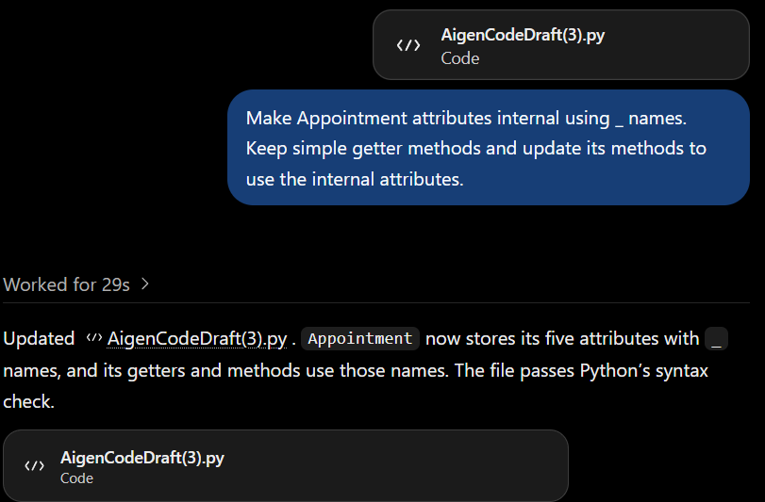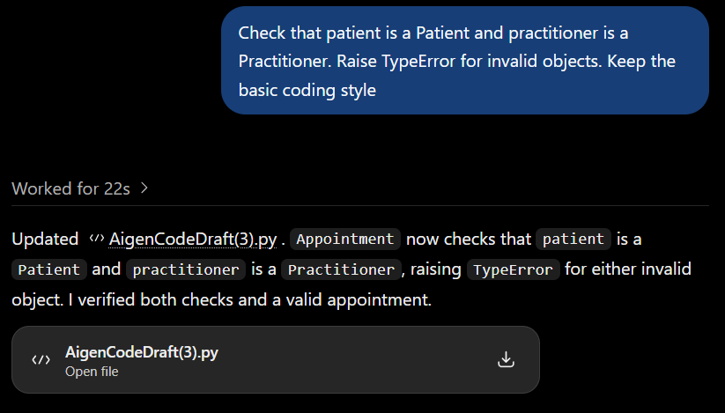

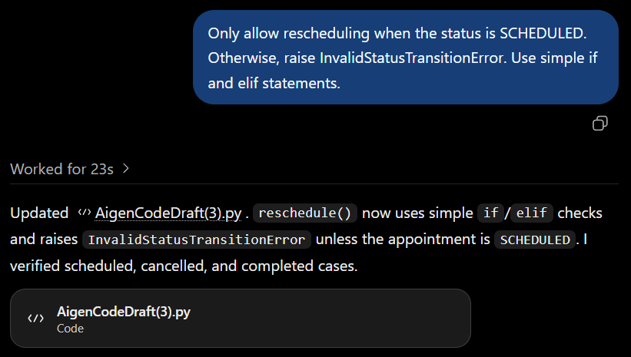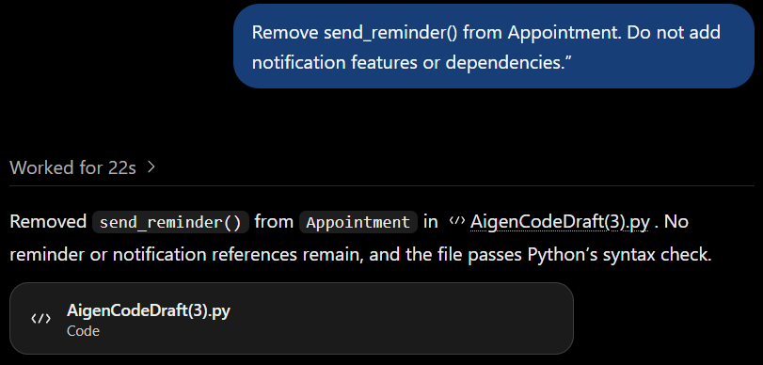

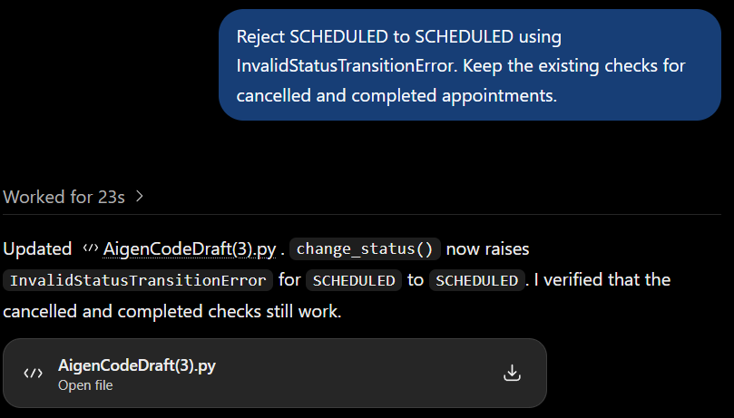

Suggested AI prompt
Act as a Python pair programmer. Implement only the Appointment class from the approved SmartCare UML. Use type hints and an AppointmentStatus enum. Cancelled appointments remain as objects. Do not add database, UI, notification or service classes. Protect status transitions and explain any decision not directly visible in the UML.

Reflection
Which AI-generated part did you modify or reject? Why? How did the approved design constrain the AI?
After comparing the AI-generated Appointment code with the authorised UML and business rules, I made modifications. In order to prevent data from being altered directly from outside the class, I used _ to rename the Appointment properties to internal names. To ensure that the values could still be read, I maintained straightforward getter methods.
In order to verify that the practitioner is a Practitioner object and the patient is a Patient object, I additionally provided validation. The constructor reports a TypeError if the incorrect type is supplied.
I can't be can't be can't be can't be cancelled. An InvalidStatusTransitionError is raised, and the appointment must not alter. Additionally, I was also changed from being changed from SCHED.
The approved UML and the lab criteria did not include notifications, thus I eliminated the send_reminder() function. The AI was restricted by the authorised design to the specified classes, attributes, methods, relationships, and appointment status criteria. This assisted in keeping the AI from incorporating unnecessary features.

